Generate random number
from numpy import random
x = random.randint(100)
print(x) -> 93
from numpy import random
x = random.rand()
print(x) _> 0.40550794722841466
from numpy import random # 1-D array containing 5 random numebers from 0 to 100
x=random.randint(100, size=(5))
print(x) -> [46 1 8 60 63]
from numpy import random
x = random.randint(100, size=(3, 5))
print(x)
[[80 54 19 74 65]
[26 60 69 34 25]
[50 16 53 84 90]]
from numpy import random #shape of the random rand
x = random.rand(5)
print(x) -> [0.4596321 0.0039063 0.3176288 0.2739511 0.9947464]
from numpy import random
x = random.randint(100, size=(3, 5))
print(x)
[[90 99 11 30 34] [66 40 63 36 37] [63 35 89 51 58]]
from numpy import random # float
x = random.rand(5)
print(x) [0.6791930 0.0811429 0.2709453 0.2429679 0.4930338]
from numpy import random
x = random.rand(3, 5)
print(x)
[[0.03379952 0.78263517 0.9834899 0.47851523 0.02948659]
[0.36284007 0.10740884 0.58485016 0.20708396 0.00969559]
[0.88232193 0.86068608 0.75548749 0.61233486 0.06325663]]
rom numpy import random
x = random.choice([3, 5, 7, 9])
print(x) -> 9
from numpy import random
x = random.choice([3, 5, 7, 9], size=(3, 5))
print(x)
[[9 3 5 5 7] [7 5 3 3 9] [7 5 9 9 7]]
Random Data Distribution.-> All posible values abd how often ocuurs . Random Distribution. Follows probabbility density distribution
from numpy import random
x = random.choice([3, 5, 7, 9], p=[0.1, 0.3, 0.6, 0.0], size=(100))
print(x) -> 100 values betwuen 3 5 7 9 with p(x)

from numpy import random
x = random.choice([3, 5, 7, 9], p=[0.1, 0.3, 0.6, 0.0], size=(3, 5))
print(x) [[7 7 3 5 7] [7 7 7 7 5] [7 7 7 7 7]]
Random permutation
from numpy import random
import numpy as np
arr = np.array([1, 2, 3, 4, 5])
random.shuffle(arr)
print(arr) -> [4 3 5 2 1]
from numpy import random # permutations
import numpy as np
arr = np.array([1, 2, 3, 4, 5])
print(random.permutation(arr)) > [4 2 5 1 3]
Seaborn: Library (uses Matplotlib underneath) to plot graphs->visualize random distributions.
C:\Users\Your Name>pip install seaborn C:\Users\Your Name>!pip install seaborn if you use jupiter
import matplotlib.pyplot as plt
import seaborn as sns
import matplotlib.pyplot as plt
import seaborn as sns
sns.distplot([0, 1, 2, 3, 4, 5])
plt.show()
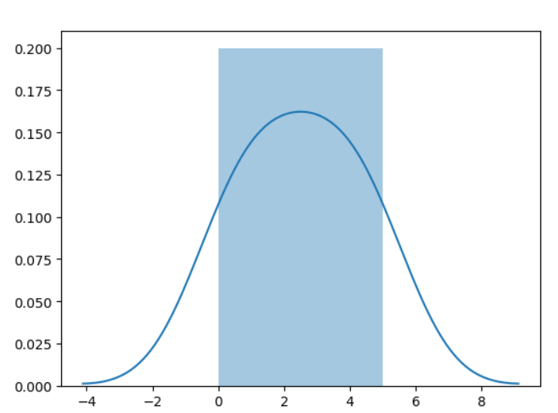
import matplotlib.pyplot as plt # Withut the histogram
import seaborn as sns
sns.distplot([0, 1, 2, 3, 4, 5], hist=False)
plt.show() - >Figure
Normal Gaussian
from numpy import random
x = random.normal(size=(2, 3))
print(x) -> [[ 1.11713711 -1.09605344 0.21857628] [ 0.11866716 2.08584981 0.62907682]]
from numpy import random. Media 2 desvest 2
x = random.normal(loc=1, scale=2, size=(2, 3))
print(x) # [[-1.29460536 2.90737862 0.91012469] [ 1.1092912 0.8424823 1.27307071]]
from numpy import random
import matplotlib.pyplot as plt
import seaborn as sns
sns.distplot(random.normal(size=1000), hist=False)
plt.show()
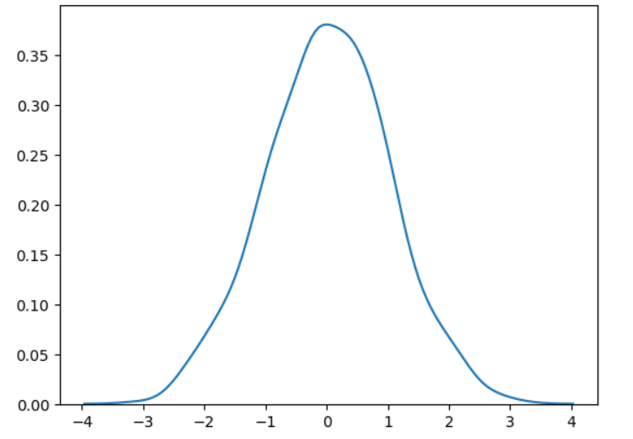
Binomial Distribution
from numpy import random
x = random.binomial(n=10, p=0.5, size=10)
print(x) -> [6 6 6 5 6 4 7 4 7 6[
from numpy import random #visualitation
import matplotlib.pyplot as plt
import seaborn as sns
sns.distplot(random.binomial(n=10, p=0.5, size=1000), hist=True, kde=False)
plt.show()
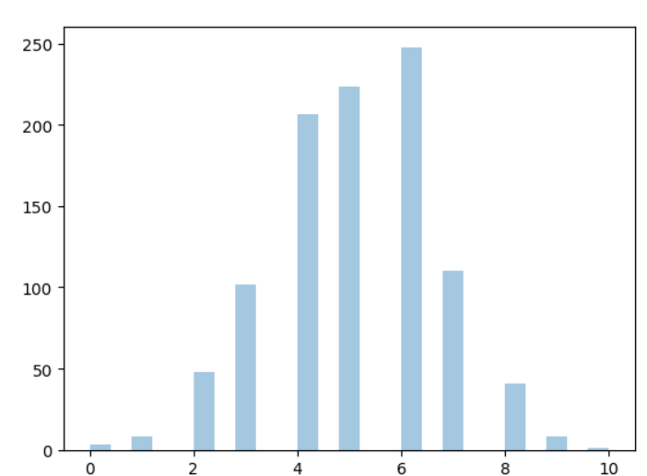
Poisson Distribution
from numpy import random
x = random.poisson(lam=2, size=10)
print(x) > [1 2 4 2 1 1 1 1 4 0]
from numpy import random # visualitation
import matplotlib.pyplot as plt
import seaborn as sns
sns.distplot(random.poisson(lam=2, size=1000), kde=False)
plt.show() _>
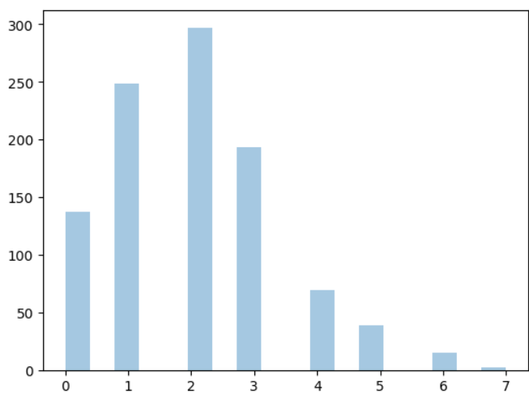
Uniform Distribution
from numpy import random
x = random.uniform(size=(2, 3))
print(x) [[0.5650699 0.21950594 0.62890073] [0.44421966 0.21209774 0.45244998]]
from numpy import random #visualitaion
import matplotlib.pyplot as plt
import seaborn as sns
sns.distplot(random.uniform(size=1000), hist=False)
plt.show()
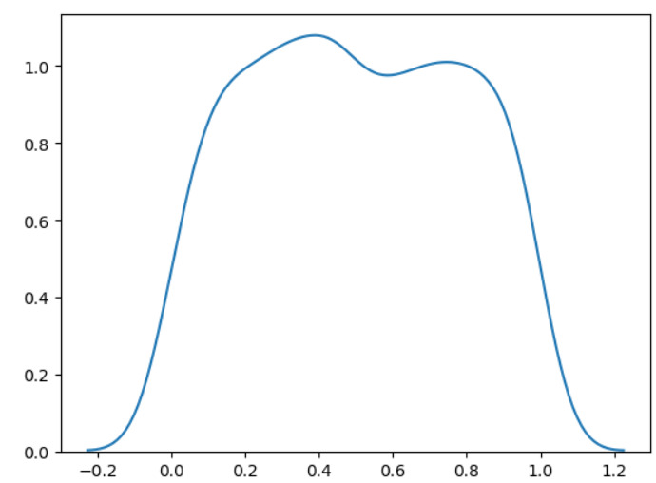
Logistic Distribution. Use to describe growth. It has three parameters: loc - mean, where the peak is. Default 0. scale - standard deviation, the flatness of distribution. Default 1. size - The shape of the returned array.
from numpy import random
x = random.logistic(loc=1, scale=2, size=(2, 3))
print(x) [[ 3.33573258 -2.48097284 -4.86613046] [ 6.14397477 0.02257166 8.17140617]]
from numpy import random #visualitation
import matplotlib.pyplot as plt
import seaborn as sns
sns.distplot(random.logistic(size=1000), hist=False)
plt.show()
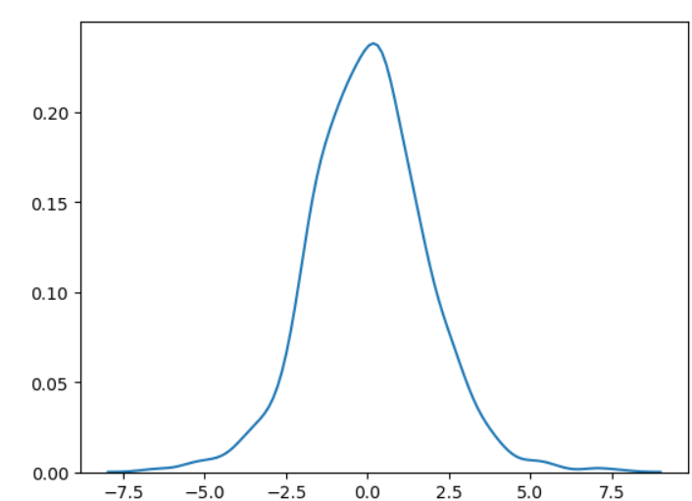

Difference Between Logistic and Normal Distribution, Both distributions are near identical, but logistic distribution has more area under the tails, meaning it represents more possibility of occurrence of an event further away from mean. For higher value of scale (standard deviation) the normal and logistic distributions are near identical apart from the peak.
Multinomial Distribution. Generalization Binomial It has three parameters: n - number of possible outcomes (e.g. 6 for dice roll). pvals - list of probabilties of outcomes (e.g. [1/6, 1/6, 1/6, 1/6, 1/6, 1/6] for dice roll).
size - The shape of the returned array.
from numpy import random
x = random.multinomial(n=6, pvals=[1/6, 1/6, 1/6, 1/6, 1/6, 1/6])
print(x) -> [2 0 1 0 2 1]
Exponential Distribution
from numpy import random
x = random.exponential(scale=2, size=(2, 3))
print(x) -> [[1.3649938 0.61535564 1.43389697] [2.05902508 3.73972808 0.16246391]]
from numpy import random Visualitation
import matplotlib.pyplot as plt
import seaborn as sns
sns.distplot(random.exponential(size=1000), hist=False)
plt.show()
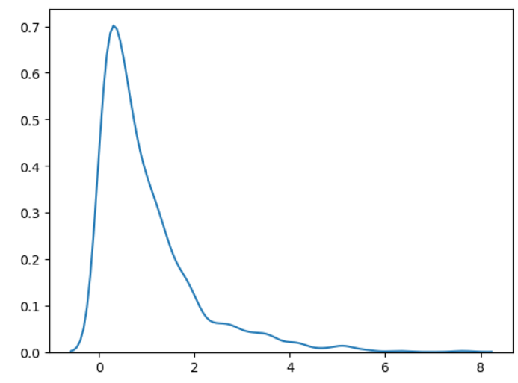
Chi square distribution. Chi Square distribution is used as a basis to verify the hypothesis. It has two parameters:
df - (degree of freedom). size - The shape of the returned array.
from numpy import random
x = random.chisquare(df=2, size=(2, 3))
print(x) [[3.1051741 1.30390788 0.44600976]
[0.36514539 0.06632777 0.72327708]]
from numpy import random # visualitation
import matplotlib.pyplot as plt
import seaborn as sns
sns.distplot(random.chisquare(df=1, size=1000), hist=False)
plt.show()
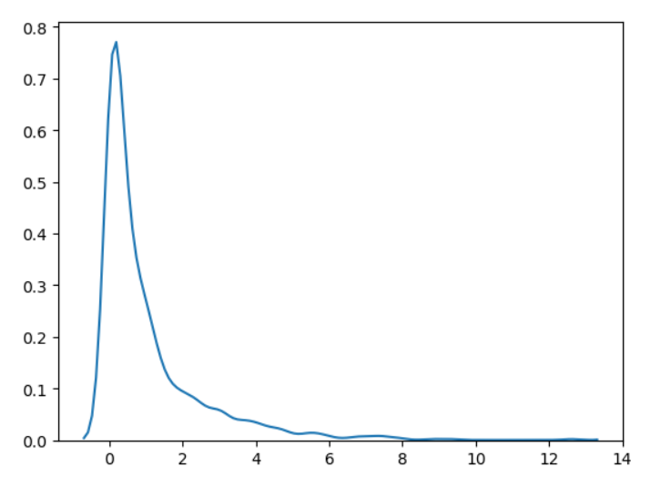
Rayleigth Distribution
from numpy import random
x = random.rayleigh(scale=2, size=(2, 3))
print(x) [[1.52617279 2.8331039 4.01967263]
[1.5076399 1.77118126 2.92759241]]
from numpy import random
import matplotlib.pyplot as plt
import seaborn as sns
sns.distplot(random.rayleigh(size=1000), hist=False)
plt.show()
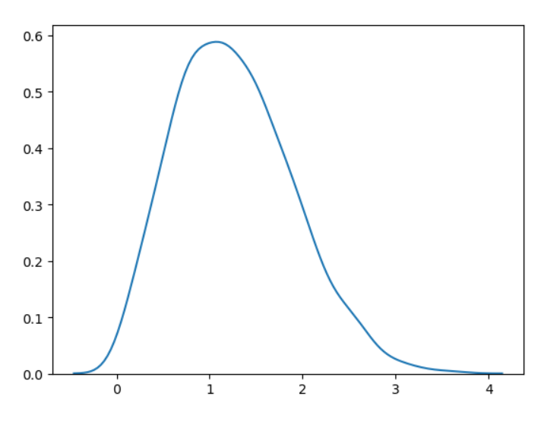
Pareto Distribution
from numpy import random
x = random.pareto(a=2, size=(2, 3))
print(x) [[0.8687304 0.94520022 0.04219127]
[0.28942454 1.4686284 3.12342539]]
from numpy import random
import matplotlib.pyplot as plt
import seaborn as sns
sns.distplot(random.pareto(a=2, size=1000), kde=False)
plt.show()
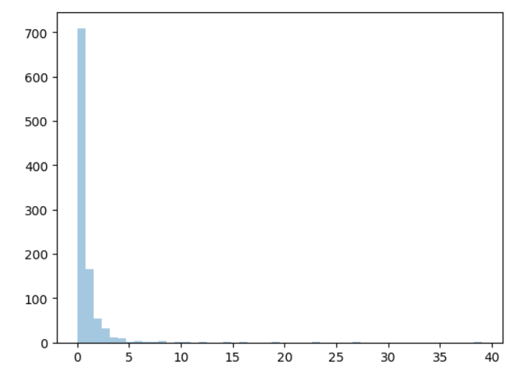
ZIPF distribution. Are used to sample data based on zipf's law. Zipf's Law: In a collection, the nth common term is 1/n times of the most common term. E.g. the 5th most common word in English occurs nearly 1/5 times as often as the most common word. It has two parameters: a - distribution parameter. size - The shape of the returned array
from numpy import random
x = random.zipf(a=2, size=(2, 3))
print(x) [[105 4 1] [ 3 3 1]]
from numpy import random # Visualitation
import matplotlib.pyplot as plt
import seaborn as sns
x = random.zipf(a=2, size=1000)
sns.distplot(x[x<10], kde=False)
plt.show()
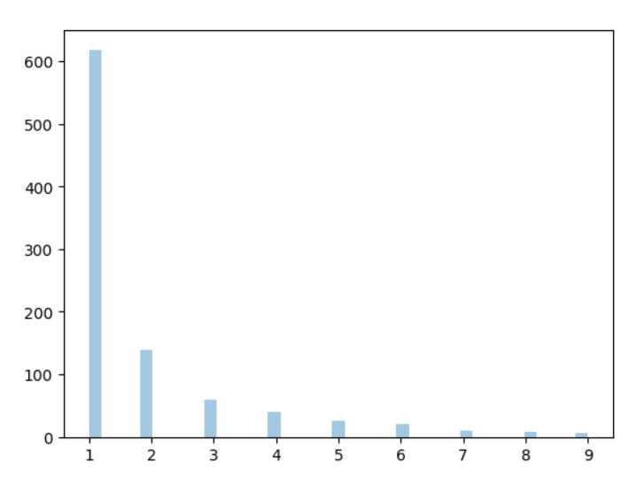
(x)

